**CARDIOVASCULAR SYSTEM**

1. **Circulatory system**

**Role**

This system ensures body cell receives the needed nutrients and oxygen required for body functions and removal of waste products like Carbon dioxide back into the circulation.

**Composition of circulation system**

* Heart
* Blood vessels
* Blood

**Types of circulation**

* **Coronary circulation (cardiac)** – it is the circulation of blood in the blood vessels that supply the heart muscles (myocardium).

**NB:** Cardiac veins drain away blood after it has been deoxygenated.

* **Portal circulation (hepatic)** – the circulation of nutrients (digestive system) rich blood between the gut (digestive system) and liver.
* **The pulmonary circulation** – the circulation of deoxygenated blood from the right side of the heart.
* **The systematic circulation-** the circulation of oxygenated blood form the left side of the heart out to the rest of the body and de oxygenated blood back to the right side of the heart.

**The heart**

* The heart is a muscular organ composed of cardiac muscles.
* It lies in the thoracic cavity in the mediastinum between the two lungs.
* It is cone shaped or triangular shaped. The base (broad area) is above and the apex (narrow area) is below.
* It is divided into right and left parts by a septum.
* Each side is also divided into an atrium and a ventricle.
* The atrium receives the blood. The blood then passes through the tricuspid or bicuspid valves into the ventricle.
* The ventricles pumps the blood out of the heart into either the pulmonary circulation or the systemic circulation.

**Layers of the heart**

The heart is composed of three layers of tissue.

* Pericardium – outer layer
* Myocardium- middle layer (this is the muscular layer)
* Endocardium – inner layer

**Function:** It pumps blood through out the body.

**Diagram of the heart**

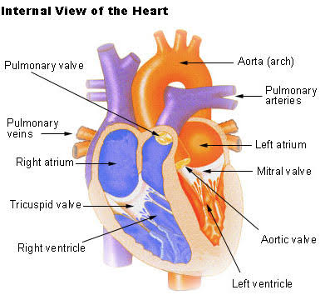

**Blood circulation to heart, pulmonary and systems circulation**

* Blood returning to the heart from the body passes through the superior and inferior venacava.
* Venacavae empty the blood into the right atrium.
* From the right atrium blood passes through the tricuspid valve into the right ventricle.
* The right ventricle pumps the blood through the pulmonary circulation. There is a pulmonary valve guarding the beginning of the pulmonary artery so that blood does not flow back into the right ventricle.
* The pulmonary artery carry blood into the lungs so that it gives off carbon dioxide and picks up oxygen.
* In the lungs blood is collected by four pulmonary veins which carry the oxygenated blood to the left atrium.
* The blood passes through the bicuspid (mitral valve) into the left ventricle
* The left ventricle pumps blood into the systemic circulation through the aorta.
* The beginning of aorta is guarded by the aortic valve which prevents blood from flowing backwards.
* If any of the hart valves become infected by disease, they will not be able to close properly.
* The blood will flow backwards through the valves.
* The aorta is divided into two;
* Thoracic aorta
* Abdominal aorta
* Thoracic aorta has the following parts
* Ascending aorta
* Arch of aorta
* Descending aorta
* Abdominal aorta has the following small branches;
* Oesophageal arteries
* Right and left intercostals arteries
* Bronchial arteries.

**Diagram of blood circulation through heart, pulmonary and systematic circulation.**

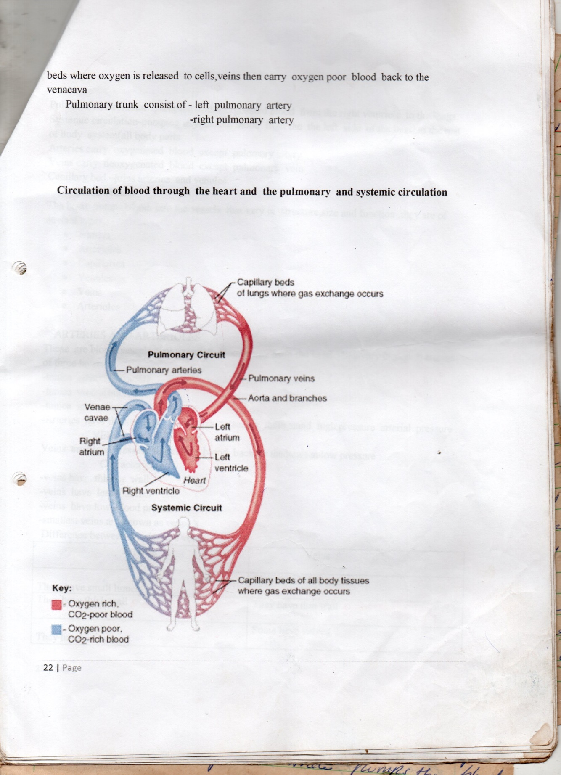

**Blood vessels**

* The heart pumps blood into the vessels that vary in structure size and function.
* They are of several types;
  + Arteries
  + Arterioles
  + Veins
  + Venules
  + Capillaries

**Arteries and arterioles**

* These are blood vessels that transport blood away from the heart.
* They vary in size
* The walls of arteries and arterioles are very strong in order to withstand the pressure of the heart pumping.
* Their walls are also elastic in order to stretch to a reasonable size.
* The aorta is the main artery which carry blood away from the heart.
* From the arch of aorta three important arteries branch off. These includes;
* Brachiocephalic trunk
* Left common carotid artery
* Left subclavian artery
* The common carotid arteries take blood to the head.
* Sub clavion arteries take blood to the upper extremity.
* Arteries branch forming smaller arteries which branch further forming arterioles.
* Arterioles have smooth muscle walls which are under the automatic nervous system control.
* ANS cause arterioles to construct thereby increasing blood pressure or cause them to dilate to decrease blood pressure.
* The small arteries join with one another forming a network of arteries.
* This network is important because if one arteriole is blocked, blood will still have other routes to follow in order to reach the tissue that need to be supplied.
* These other routes are called collateral circulation.
* Arterioles branch to form a network of capillaries which are very small vessels with thin walls.
* Oxygen and nutrients pass outwards through these thin walls to the tissues.
* Carbon dioxide and other waste products pass into the capillaries to be carried away.
* Major arteries run deep in the limbs protected by other structures.
* They usually pass across the flexor surfaces of joints which are more protected than the extension surfaces.
* Arteries and arterioles consist of three layers;
* Tunica adventitia – outer layer
* Tunica media – middle layer
* Tunica intima – inner layer

**Veins and venules**

* These are blood vessels that return blood back to the heart at low pressure.
* The capillaries are continuous with venules which join together to form veins.
* The veins join to form larger veins.
* Eventually the larger veins join to form the superior and injerior venacavae.
* Veins carry blood to the heart.
* Veins have valves which prevents blood from flowing backward.
* Blood is propelled through venous system by contraction of skeletal muscles which milks blood along the vessels.
* The great veins at the thoracic cavity includes;
* Right and left brachiocephalic veins
* Superior vena cave
* Inferior vena cava

**NB:** The brachiocephalic veins joints to form the superior vena cava

**Difference between arteries and veins**

|  |  |
| --- | --- |
| **Arteries** | **Veins** |
| * They have small lumen * They have thick walls * They have elastic walls * They have no valves * Have muscular walls * Have high blood pressure * Small arteries are known as arterioles * Carry blood away from heart * Carry oxygenated blood except pulmonary artery. * Blood in arteries is bright red * They appear circular in shape | * They have wide lumen * They have thin walls * They have less elastic walls * Some have valves * Have less muscles * Have low blood pressure * Smallest veins are known as venules. * Carry blood back to heart * Carry deoxygenated blood except pulmonary vein. * Blood in veins is dark red. * They appear oval in shape |

**The capillaries**

* The small arteries known as arterioles break u into a number of minute vessels called capillaries.
* The walls of a capillary are composed of a single layer of endothelial cells which is very thin and permits the passage of water and other small molecule substances.
* Blood cells and large molecule substances such as plasma proteins do not pass-through capillary walls.

**Diagram showing an artery, vein and capillary lumen**

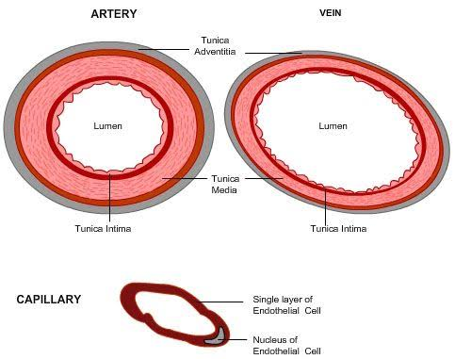

**Blood**

* Blood is a fluid connective tissue.
* It provides communication between cells of the body and the external environment.
* The body contains about 5 litres of blood.
* Blood in the blood vessels is in constant motion.
* This helps to maintain a constant stable environment in body cells.
* Blood Ph is maintained at 7.35 – 7.45.
* This makes it an alkaline not an acid.

**Composition of blood**

1. Plasma
2. Blood cells

* Red blood cells (erythrocytes)
* White blood cells (leukocytes)
* Platelets

1. Organic substance e.g.

* Urea
* Uric acid
* Oreatinine

1. Hormone – these are chemical messenger from endocrine glands.
2. Enzymes- these are catalysts which speed up chemical reaction.
3. Gases

* Oxygen
* Carbon dioxide
* Nitrogens

1. Plasm proteins

* Albumin
* Globulin
* Fibrinogen

**Functions of blood**

* Transport oxygen to lungs, tissues and remover carbon dioxide.
* Transport nutrients and hormones.
* Forming blood clots to prevent excessive blood loss- using platelets.
* Carry cells and antibodies that fight infection.
* Blood is fluid connective tissue
* Blood regulate body temperature.
* Blood brings waste products to the kidneys and liver.